Assignment 9.4
K.Sunny
HTNO: 2303A52444
Batch: 43
Task 1:
Prompt:
You are a senior Python developer working on a shared codebase. Generate professional Google-style docstrings for every function in the following Python code.
Each docstring must include:
- A brief description of the function
- Parameters with data types
- Return values
- At least one example usage
- Mention edge cases if applicable
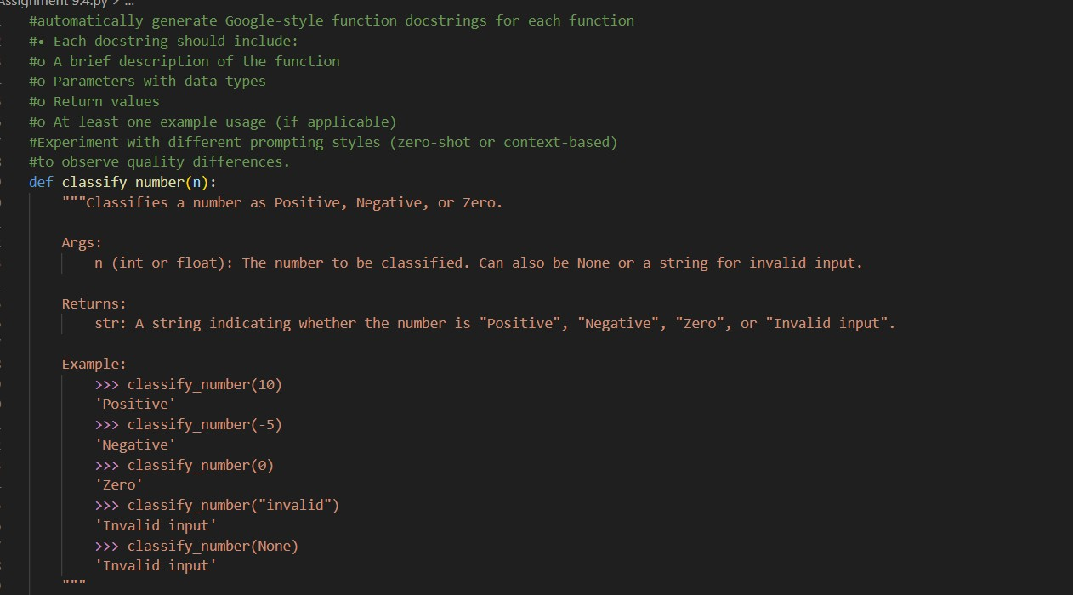
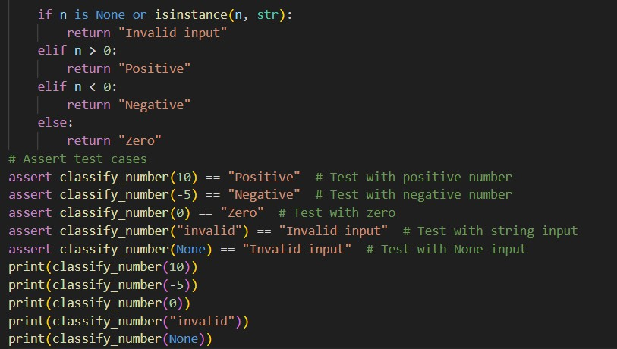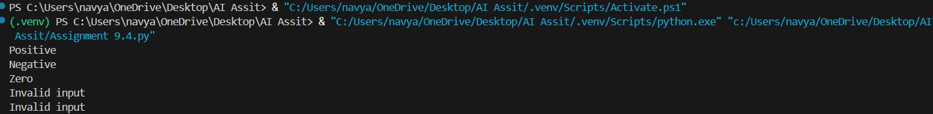
Observations:
Zero-shot prompting works well for simple functions
• Without giving examples, the model still generated:
    - Description Arg o Returns
    - Example usage
Output followed Google docstring structure correctly The docstrings contained:
  - Summary line
  - Arg section
  - Returns section
  - Examples section
Task 2:
Prompt:
Insert inline comments into the following Python script.
Rules:
- Add comments ONLY for complex or non-obvious logic
- Do NOT comment simple Python syntax
- Focus on explaining WHY the logic exists
- Keep the code clean and avoid clutter
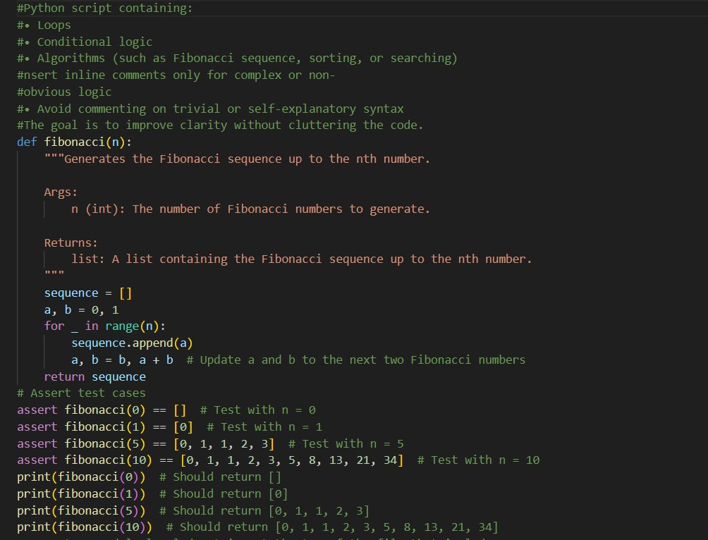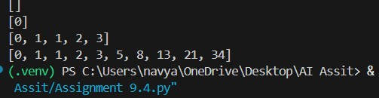

Observations
  - Model adds comments only for complex logic Example:
  - a, b = b, a + b # Update a and b to next numbers
    - Correct: this line is not obvious for beginners.
  - Avoided over-commenting
    - Did NOT comment trivial lines like:
      - sequence = []
      - return sequence
  - Improved code readability
    - Comments explain why, not what.
  - Follows clean-code principle
    - Good balance between documentation and clutter.
Conclusion
AI is effective at adding useful inline comments without cluttering code
Task 3:
Prompt:
You are preparing a Python module for a repository.

Generate a professional multi-line module-level docstring that includes:
- Purpose of the module
- Required libraries or dependencies
- Description of key functions and classes
- Example usage of the module

Tone: Clear and professional.
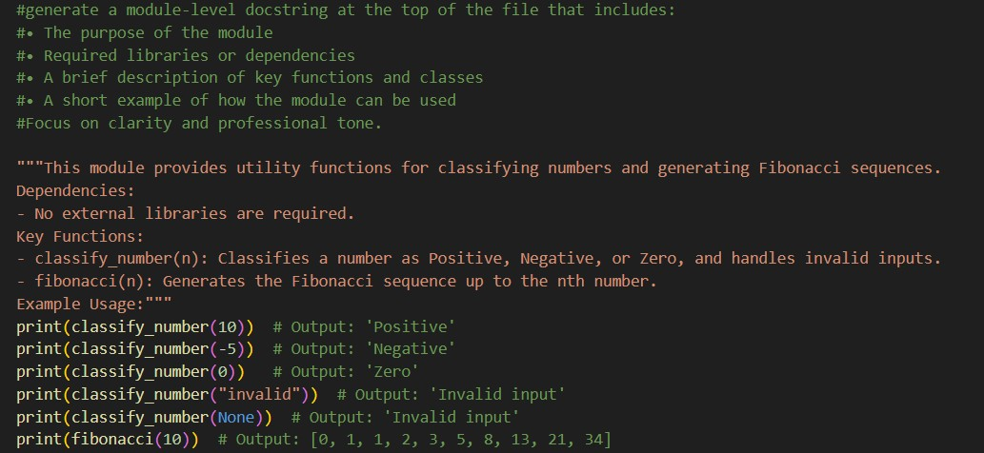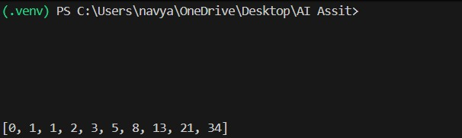
Observations
  - All required sections were included o Purpose of module ✔ o Dependencies ✔ o Key functions ✔ o Example usage ✔
  - Professional tone
    - Looks like real production documentation.
  - Improves project usability
    - New developers can understand file purpose quickly.
  - No unnecessary technical jargon o Beginner-friendly explanation.
Conclusion
AI is very strong at writing module-level documentation
Task 4:
Prompt: Convert the developer inline comments inside the following Python functions into Google-style docstrings.

Requirements:
- Preserve the original meaning of the comments
- Remove redundant inline comments after conversion
- Include Arg, Returns, and Examples sections
- Keep the documentation concise and professional
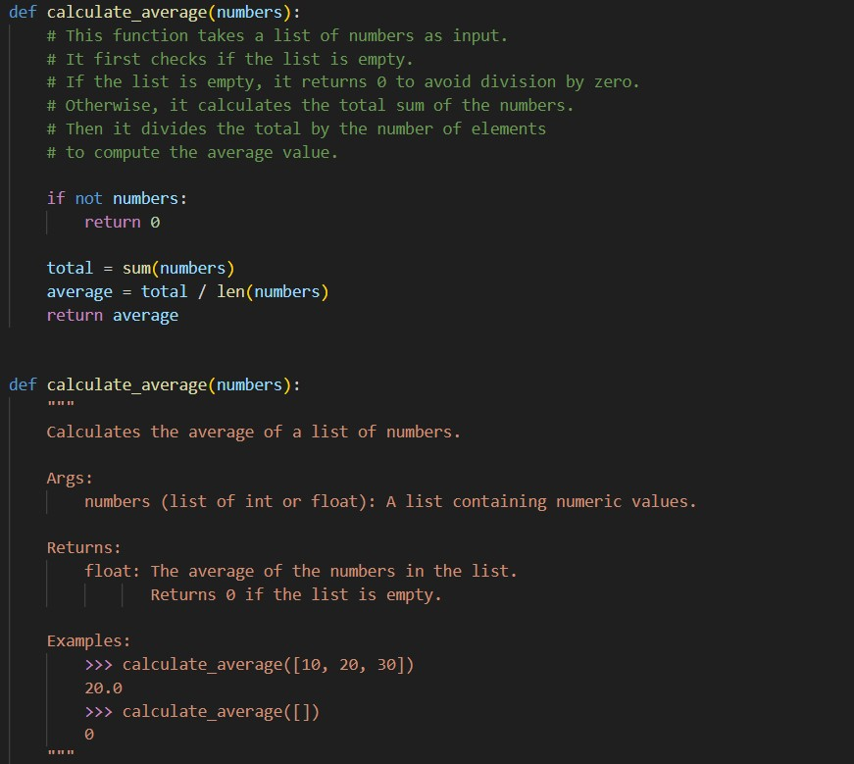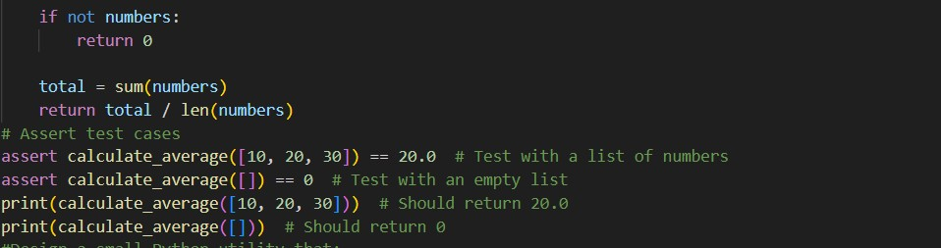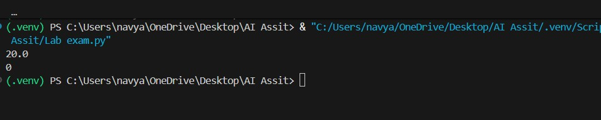
Observations
  - Meaning preserved correctly Original comments: o Check empty list o Avoid division by zero
    - Compute sum and average
All were preserved in docstring.
  - Removed redundant comments o Inline comments are no longer needed. o Code looks cleaner.
  - Docstring became reusable documentation
    - Can now be used by IDEs & documentation tools.
  - Improved maintainability
    - Documentation stays attached to function.
Conclusion
AI is very effective for refactoring comments into professional docstring

Task 5:
Prompt: Create a Python utility that automatically adds documentation to Python files.
The script must:
- Read a given .py file
- Use AST to detect functions and classes
- Insert placeholder Google-style docstrings for each detected function or class
- Save the modified file as a new file
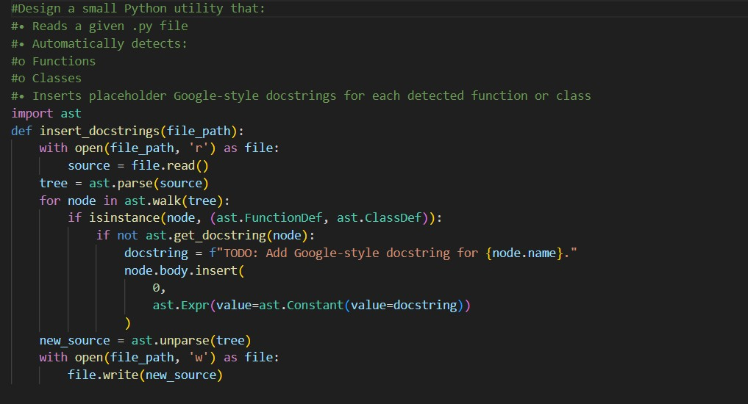
Observations
  - Automation capability demonstrated
    - Can process entire Python files automatically.
  - AST is powerful for code analysis
    - Detects structure without executing code.
  - Good for large projects
    - Helps enforce documentation standards.
  - Placeholder approach is practical
    - Developers can later replace TODO docstrings.
  - Limitation o Generated docstrings are generic. o Still needs AI/manual completion.
Conclusion
AST approach is useful for scaffolding documentation at scale.

